TEST 4
SECTION 1
Questions 1 – 7
Complete the table below.
Write ONE WORD AND/OR A NUMBER for each answer
Event | Cost | Venue | Notes
Jazz band | Example  Tickets available for £ …..15….. | The 1…………. school | Also appearing: Carolyn Hart (plays the 2…………)
Duck races | £1 per duck | Start behind the 3…………. | Prize: tickets for 4………… held at the end of the festival.  Ducks can be bought in the 5………….
Flower show | Free | 6…………. Hall | Prizes presented at 5 pm by a well-known 7………….

Questions 8-10
Who is each play suitable for?
Write the correct letter, A, B or C, next to Questions 8-10
A mainly for children
B mainly for adults
C suitable for people of all ages

Plays
8 The Mystery of Muldoon …………..
9 Fire and Flood …………..
10 Silly Sailor …………..

SECTION 2
Questions 11 – 16
What does the speaker say about each of the following collections?
Choose SIX answers from the box and write the correct letter, A-G, next to Questions 11-16.
Comments
A was given by one person
B was recently publicised in the media
C includes some items given by members of the public
D includes some items given by the artists
E includes the most popular exhibits in the museum
F is the largest of its kind in the country
G has had some of its contents relocated

Collections
11 20th- and 21st-century paintings
12 19th-century paintings
13 Sculptures
14 ‘Around the world’ exhibition
15 Coins
16 Porcelain and glass

Questions 17-20
Label the plan below.
Write the correct letter, A-H, next to Questions 17-20.
Basement of museum
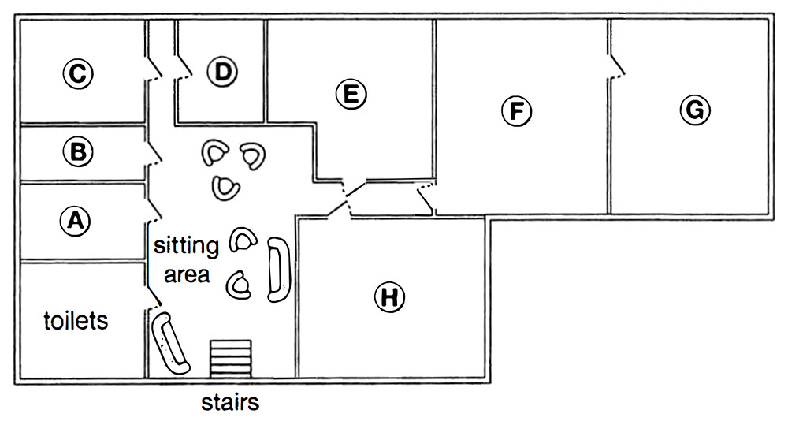
17 restaurant …………..
18 café …………..
19 baby-changing facilities …………..
20 cloakroom …………..

SECTION 3
Questions 21 and 22
Choose TWO letters, A-E.
Which TWO characteristics were shared by the subjects of Joanna’s psychology study?
A They had all won prizes for their music.
B They had all made music recordings.
C They were all under 27 years old.
D They had all toured internationally.
E They all played a string instrument.

Questions 23 and 24
Choose TWO letters, A-E.
Which TWO points does Joanna make about her use of telephone interviews?
A It meant rich data could be collected.
B It allowed the involvement of top performers.
C It led to a stressful atmosphere at times.
D It meant interview times had to be limited.
E It caused some technical problems.

Questions 25 and 26
Choose TWO letters, A-E.
Which TWO topics did Joanna originally intend to investigate in her research?
A regulations concerning concert dress
B audience reactions to the dress of performers
C changes in performer attitudes to concert dress
D how choice of dress relates to performer roles
E links between musical instrument and dress choice

Questions 27-30
Choose the correct letter, A, B or C.
27 Joanna concentrated on women performers because
A women are more influenced by fashion.
B women’s dress has led to more controversy.
C women’s code of dress is less strict than men’s.
28 Mike Frost’s article suggests that in popular music, women’s dress is affected by
A their wish to be taken seriously.
B their tendency to copy each other.
C their reaction to the masculine nature of the music.
29 What did Joanna’s subjects say about the audience at a performance?
A The musicians’ choice of clothing is linked to respect for the audience.
B The clothing should not distract the audience from the music.
C The audience should make the effort to dress appropriately.
30 According to the speakers, musicians could learn from sports scientists about
A the importance of clothing for physical freedom.
B the part played by clothing in improving performance.
C the way clothing may protect against physical injury.

SECTION 4
Questions 31 – 40
Complete the notes below.
Write ONE WORD ONLY for each answer.
The use of soil to reduce carbon dioxide (CO2) in the atmosphere
Rattan Lal:
● Claims that 13% of CO2 in the atmosphere could be absorbed by agricultural soils
● Erosion is more likely in soil that is 31…………….
● Lai found soil in Africa that was very 32……………
● It was suggested that carbon from soil was entering the atmosphere
Soil and carbon:
● plants turn CO2 from the air into carbon-based substances such as 33……………
● some CO2 moves from the 34……………. of plants to microbes in the soil
● carbon was lost from the soil when agriculture was invented
Regenerative agriculture:
● uses established practices to make sure soil remains fertile and 35……………..
● e.g. through year-round planting and increasing the 36…………… of plants that are grown
California study:
● taking place on a big 37…………….. farm
● uses compost made from waste from agriculture and 38………………
Australia study:
● aims to increase soil carbon by using 39……………… that are always green
Future developments may include:
● reducing the amount of fertilizer used in farming
● giving farmers 40……………. for carbon storage, as well as their produce

